1. What’s going on here:

Why are the yellow dots connected with a yellow line? Same with red dots?

1. The Margin Cushion over time and the Cushion dollar buffer are interesting, but I would really LOVE to have Asset Percent Cushion And Asset Dollar Cushion over time. Why? Because I as a trader / investor have a less good handle on how equity value bounces around, especially when markets are stressed, because the portfolio leverage tends to be lots higher in moments like that, so equity bounces around even more violently. ULTIMATELY, what I want to know, is, given a particular level of leverage, how much cushion does the ASSET have, before I get subjected to a margin call. Can you build me a graph of this? Lets discuss if you think I am off-base and/or missing something important- I value your input!!!

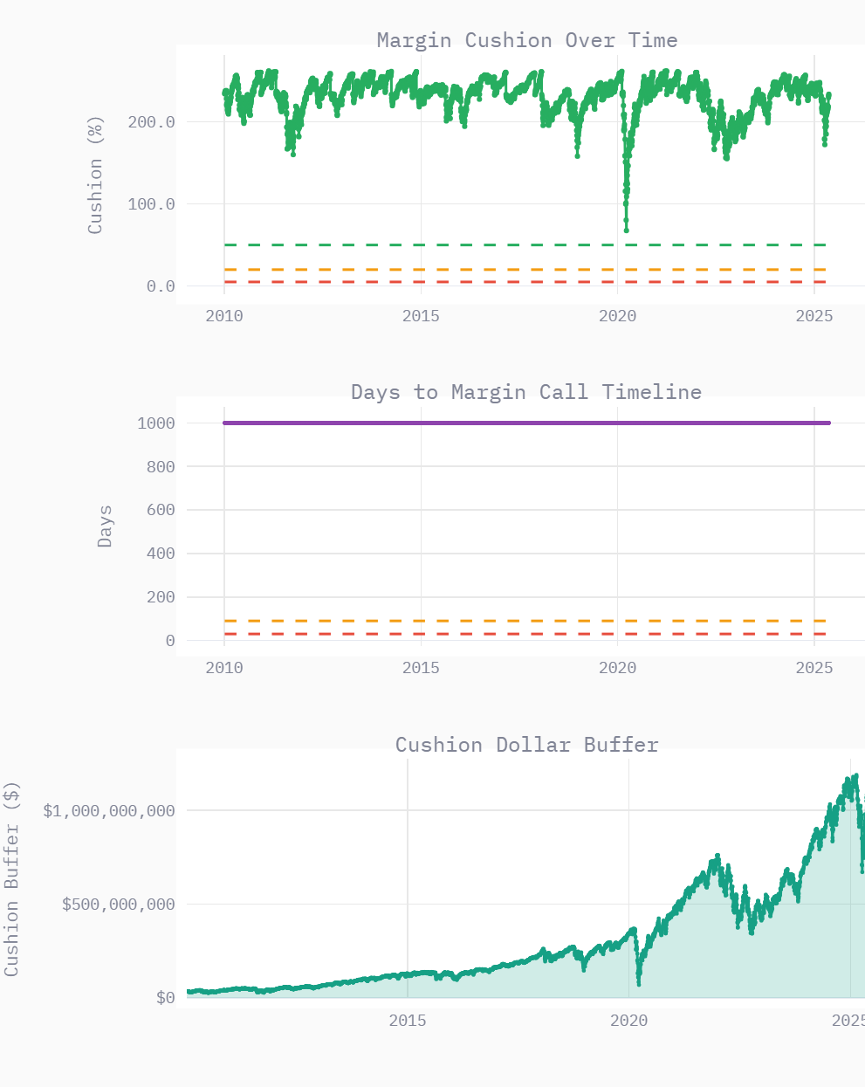

1. Benson- Here’s a new project. Lets call itL the ADE project. I want : An interactive visualization with a line chart (showing three lines) and a bar chart that updates based on a slider selecting a specific time point. I want the bar chart to be the stacked side by side thing showing the relationship between A, D, E.

Here’s a picture where I’m trying to get across this idea:

1. Benson, with the back tester, can I setup something that will plot output values for a range of input values? In other words, I might run the backtester at 1.5 leverage and write down the performance, then 1.6 leverage and write down the performance, and so on.

Instead, is there a way to mechanically run it at all these values and plot the performance?